**FORWARD FORECAST OF STOCK PRICE USING SLIDING-WINDOW**

**METAHEURISTIC-OPTIMIZED MACHINE LEARNING REGRESSION**

**EXISTING SYSTEM**

* Time series forecasting consists of a research area designed to solve various problems, mainly in the financial area. The objective to reduce financial risks is obvious when one wants to analyze financial markets and, for this reason, it is necessary to assure a good accuracy in forecasting tasks.
* Support vector regression (SVR), a variant of the SVM, was developed by Vapnik et al. (1995). SVR is typically used to solve nonlinear regression problems by constructing the input-output mapping function. The least squares support vector regression (LSSVR) algorithm is a further development of SVR by Suykens (2001) and involves equality instead of inequality constraints, and works with a least squares objective function. The LSSVR approach considerably reduces computational complexity and increases efficiency compared to standard SVR.
* The Firefly Algorithm (FA), which is a nature-inspired metaheuristic method, has recently performed extremely well in solving various optimization problems such as stock price forecasting and electricity price prediction. The standard FA was developed by modelling the behaviour of tropical fireflies. Notably, the smart firefly algorithm-based LSSVR has been demonstrated to be very effective in solving complex problems in civil engineering.
* Previous presents a novel approach, based on a metaheuristic firefly algorithm and least squares support vector regression (MetaFA-LSSVR), to constructing a stock price forecasting expert system, with the aim of improving forecasting accuracy.

**PROPOSED SYSTEM**

* To generalize the application of the proposed system, our work uses the existing system to estimate other stocks in similar emerging markets and mature markets, such as Vietnam, Indonesia, China, Japan, Hong Kong, Korea, Singapore, Europe, USA and India.
* The system can be extended to analyze multivariate time series data and import raw dataset directly.
* Profit can be maximized even when the construction corporate stock market is bullish. Finally, the development of a web-based application has been considered to improve the user-friendliness and usability of the expert system.

**INPUT:** Stock Dataset in a file, preferably an Excel datasheet

The input stock data for companies is obtained by **Quandl APIs** that automatically provide function calls to import the data directly, or alternatively, to download them.

As an example, consider the stock price of **The Coca-Cola Company** for **3 months**

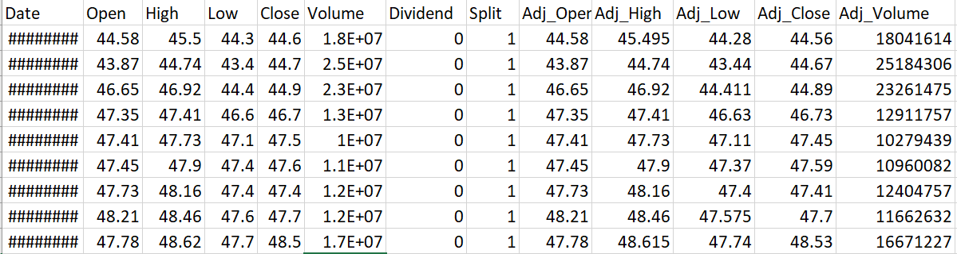

The graph for the sample collection of the above stock is as follows

Consider the above data to be the complete available stock prices. We shall split them into three parts:

1. Training set
2. Cross-validation Set
3. Test Set

We can predict the stock prices by applying our proposed method in a generalized way.

**OUTPUT:** A decimal number that predicts the closing price of the stock for a given day.

The error increases with the number of days in advance for which the prediction is made. The output will be as follows.

*Closing price*

|  |
| --- |
| 45.7 |
| 46.6 |
| 46.8 |
| 47.4 |
| 46.7 |
| 46.5 |
| 46.2 |
| 46.2 |
| 45.9 |

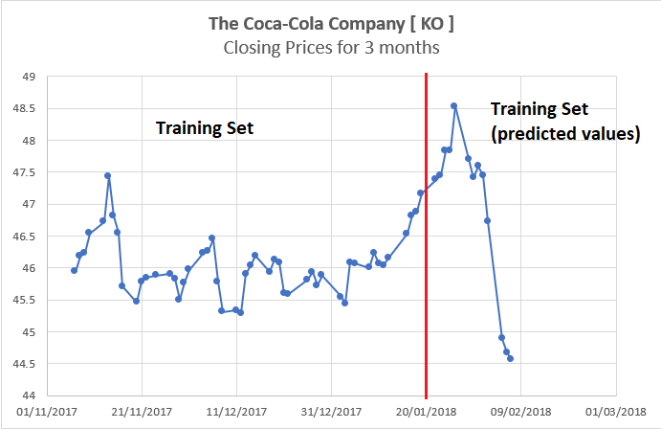

Thus, as we can see above in our proposed method, we train the data using the training data set at the beginning of the stock data. We use this data to predict and forecast the test and cross validation stock prices.

We should be able to show that the difference between the predicted value and the actual value of the closing price in the test dataset must be as minimum as possible.

We can plot the data on a graph using Python’s **matplotlib** library or using MATLAB.

*****